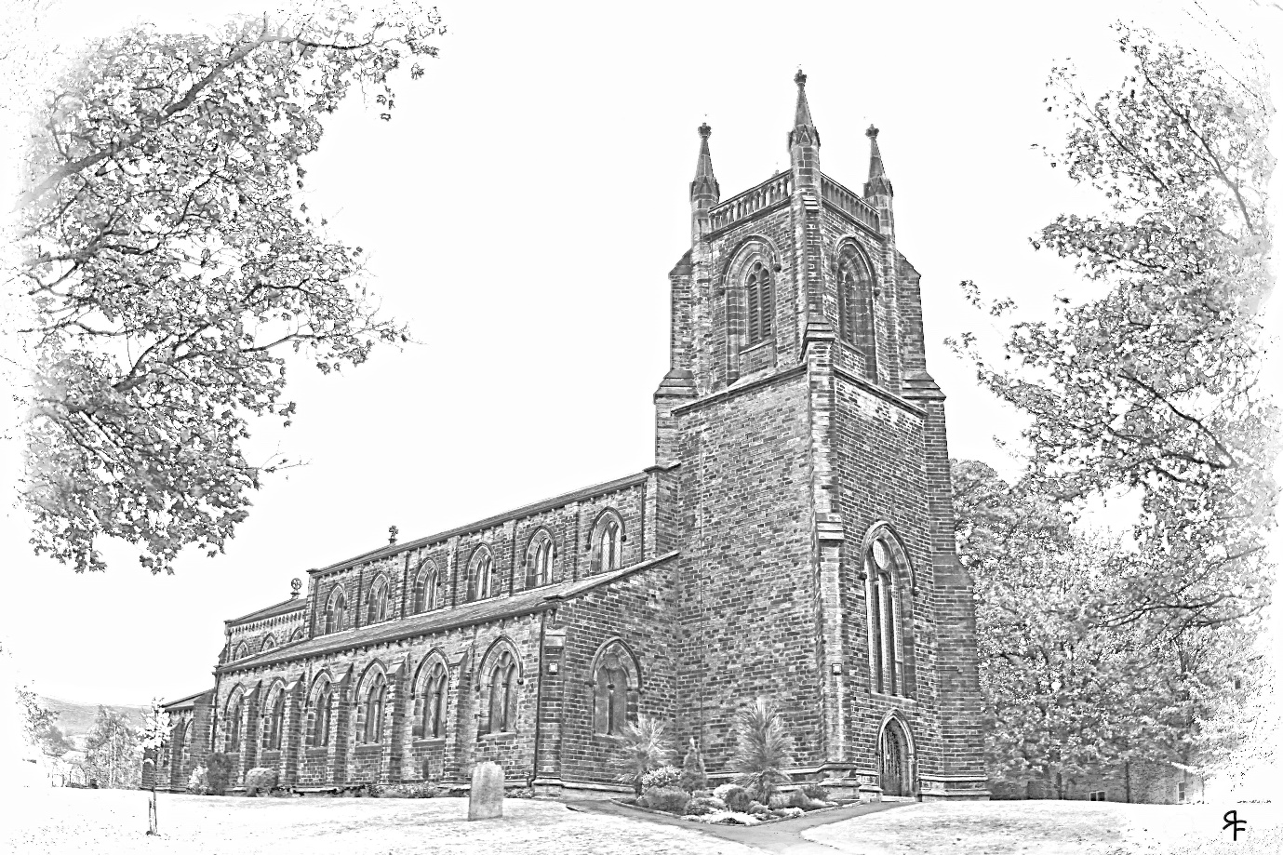

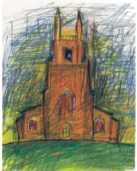

**Carol Service**: Will be held at 2pm, Christ Church, Skipton on Wednesday 11th December. This will be the 26th Craven u3a Carol service. The service will include Madrigals, performance by our Recorder group and an organ music.

Everyone is more than welcome to our annual service. After the service, refreshments will be available at the rear of the church. So please come along and join us. Any offers of mince pies would be gratefully received.

The Event is being organised on our behalf by Albert Bonham and Kenneth Jackson, massive thanks to both.

The collection will be split 50:50 between the church and Sue Ryder.